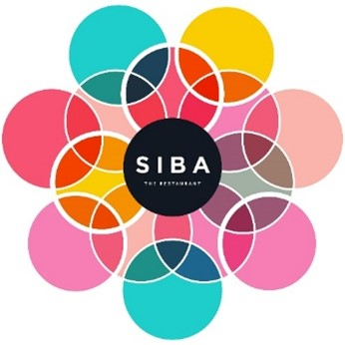

PLEASE NOTE:

WE ALSO CATER FOR VEGETARIAN, PESCATERIAN AND VEGAN DIETS

A 12.5% GRATUITY WILL BE ADDED TO THE CHECK.

WE ENJOYED HOSTING YOU AND WE LOOK FORWARD  
TO SEEING YOU NEXT TIME!

.

PLEASE NOTE:

WE ALSO CATER FOR VEGETARIAN, PESCATERIAN AND VEGAN DIETS

A 12.5 % GRATUITY WILL BE ADDED TO THE CHECK.

WE ENJOYED HOSTING YOU AND WE LOOK FORWARD  
TO SEEING YOU NEXT TIME!

# **BREAD COURSE**

# THE DOMBOLO DANCE

Mini fluffy dombolo or tradition steamed bread, flavoured butters, chimichurri.

# **STARTER**

# SEARED TUNA SALAD

Sesame crusted seared tuna, with traditional grilled baby corns, carrot and cucumber ribbons with a sweet soy dressing,

Squid ink blackened twirl.

# **MAIN COURSE**

# SHARING PLATES

Chicken roulade,

Beef fillet medallion with minted jus,

Seven colour rice,

Siba’s famous chakalaka,

Beet carpaccio, pistachios, goats’ cheese and citrus dressing,

Miso roasted pumpkin wedge,

Creamed spinach,

Spicy coconut corn bites,

Sauteed seasonal vegetables and spring greens.

# **DESSERT**

SIBA’S PANNACOTTA

Coconut and vanilla pannacotta, meringues, apple sorbet, cream cheese frosting, mixed berry coulee and fresh berries.

**THE MENU**

SIBA’S SUNDAY LUNCH 795

WINE PAIRING 550

# **BREAD COURSE**

# THE DOMBOLO DANCE

Mini fluffy dombolo or tradition steamed bread, flavoured butters, chimichurri.

# **STARTER**

# SEARED TUNA SALAD

Sesame crusted seared tuna, with traditional grilled baby corns, carrot and cucumber ribbons with a sweet soy dressing,

Squid ink blackened twirl.

# **MAIN COURSE**

# SHARING PLATES

Chicken roulade,

Beef fillet medallion with minted jus,

Seven colour rice,

Siba’s famous chakalaka,

Beet carpaccio, pistachios, goats’ cheese and citrus dressing,

Miso roasted pumpkin wedge,

Creamed spinach,

Spicy coconut corn bites,

Sauteed seasonal vegetables and spring greens.

# **DESSERT**

SIBA’S PANNACOTTA

Coconut and vanilla pannacotta, meringues, apple sorbet, cream cheese frosting, mixed berry coulee and fresh berries.

# **AFTER DESSERT**

Optional coffee or tea

**THE MENU**

SIBA’S SUNDAY LUNCH 795

WINE PAIRING 550