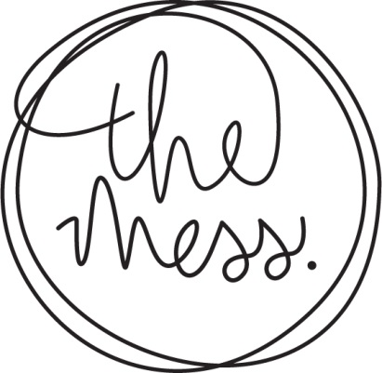

“IN THE 15TH CENTURY,
A GROUP OF PEOPLE
WHO ATE TOGETHER WAS
KNOWN AS A MESS”

ASK ABOUT OUR BLACKBOARD
SPECIALS

PLATES TO SHARE

Yoghurt & Thyme Flatbreads 20

Mezze
Confit duck rillette, pickled beetroot 45

White bean and tahini pate, pine nut
& mint vinaigrette 27

Pickled goats’ cheese with Moroccan
nut dukkha 29

BAO Sliders

Pan fried halloumi, smoked aubergine,
avocado 75

Crumbed Hake, garlic mayo & sweet
pickled red onion 75

Pulled BBQ pork shoulder, smoked
apple & charred corn slaw 75

Beef Tataki
Seared angus beef tenderloin, ponzu dressing, mooli & cucumber salad 95

Pork Belly Taco
BBQ lacquered pork belly, smoked apple &
Charred con slaw 75

Tuna Ceviche
Lime cured tuna, coriander & spring onion salad, avocado, wonton tostada 95

Squid & Chorizo
Charred baby squid, chorizo sausage, ponzu
glaze, pineapple and red pepper salsa 94

Soft Shell Crab
Creole fried soft shell crab, smokey mayo 170

Mushroom & Cauliflower
Grilled seasonal mushrooms, gruyere cauliflower puree, almond & parsley butter, radish 78

Aubergine Melanzane
Grilled aubergine, fior de latte, tomato ragout, panko & parmesan crumble 98

Cucumber & Apple Ceviche
Cucumber, apple, cabbage, sesame, ginger, coconut 70

Super Salad
Quinoa, sweet potato, pickled goat’s cheese, cranberries, avo, ponzu vinaigrette 105

MAIN PLATES

Lamb Neck
Saffron braised lamb neck, creamy polenta,
braised baby vegetables 195

Pork Belly
Confit crackling pork belly, braised red
cabbage, smoked apple, fennel jus, braised
baby vegetables 185

Hake Beccafico
Panko, parmesan & Italian herb crusted hake, caponata, basil 140

Vegetable Curry
Cape Malay vegetable curry, smoked apricot
cous cous, flatbreads, tomato chili jam 90

THE GRILL
(Sides/Sauces to be ordered separately)

300g Angus ribeye 165

200g Angus beef fillet 150

500g Pork loin ribs 180

Sides

Charred broccoli & dukkha 40
Charred butternut, seeds, lime yoghurt 45
Creamy Polenta 30
Thick cut fries 30
Side Salad 30

Sauces

Truffle mayo 25
Smokey mayo 22
Herb Butter 22
BBQ sauce 22
Creamy mushroom 30

DESSERTS
Dark Chocolate Lava Cake
Baked dark chocolate pudding, white chocolate & lime ice cream, roasted hazelnuts 65

Apple Crumble
Vanilla & hazelnut apple crumble, salted caramel ice cream 75

Fromage Blanc Eton Mess
Fromage blanc & vanilla panna cotta, meringue shards, seasonal berries & sorbet 70

Crème Brulee
Classic Crème Brulee 55

Seasonal Sorbet from Sorbetiere
Vegan Friendly 40

