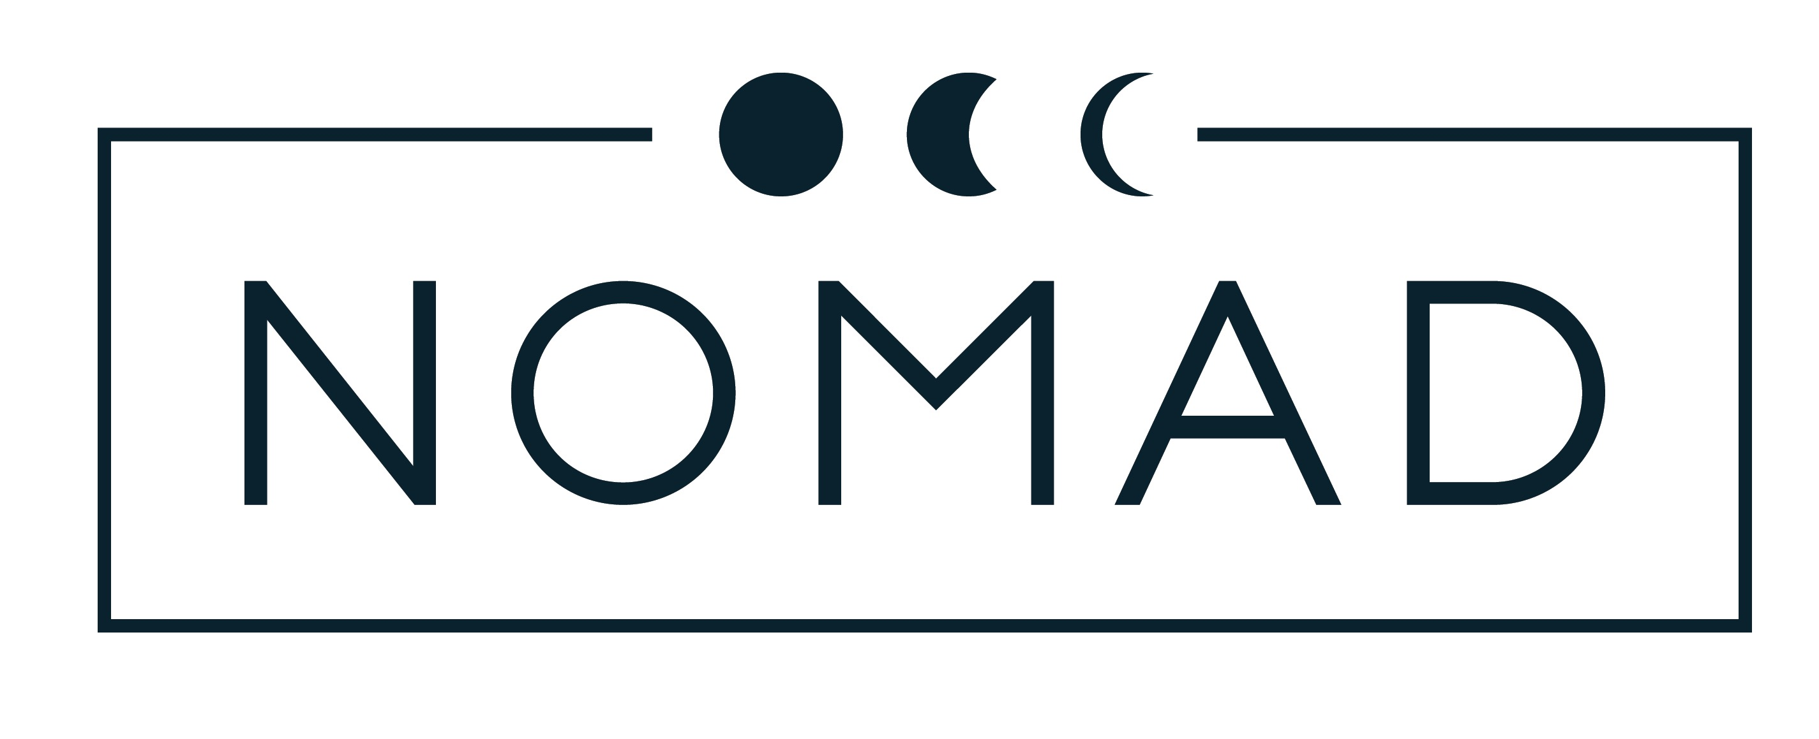
starters

Lobster tortellini in a lemon and orange buerre noisette with tomato concasse and peashoots
R95

Rare roast beef tenderloin, coriander avo puree, horseradish coleslaw and raspberry balsamic reduction
R85

Chinese five spiced duck breast with garden greens and orange-cranberry glaze - V
R85

Smoked tofu and potato dumplings with baba ganoush, roasted peppers and basil cream – V
R75

Baked sesame rice cigars with seasonal veg served with a hoisin dipping sauce
R65

Mezze platter of vegan cheese, seasonal vegetable pickles, local olives and nuts – V
Single R85 | Double R145

Mains

Vegan chilli with black beans and lentils served with homemade rotis, sambals and ricotta - V
R110

Butternut-sweet potato curry with porcini mushrooms, jeweled rice, crispy poppadum and plum chutney - V
R120

Sweet potato gnocchi served on garden greens, tomato broth and sweet potato crisps - V
R95

Wild mushroom and asparagus risotto with garden peas, smoked olive paste, vegan ricotta and truffled olive oil - V
R115

Tagliatelle with courgettes, sun-dried tomato, chorizo, biltong and a white wine-garlic cream
R115

Dukkah crusted venison loin, butternut puree, mange tout, and beluga black lentils with a blackberry jus
R145

Free-range chicken supreme served with potato puree, seasonal vegetables and chorizo-tomato sauce
R95

Flame grilled grass-fed Ribeye (300g)
R130
With your choice of
wild mushroom cream / trio of peppercorn sauce – R16
garden salad / seasonal vegetables – R20
potato puree / hand-cut potato wedges – R18

desserts

Lemon curd served with crumble and lavender ice-cream
R55

Whiskey tipsy tart with coconut crème anglaise and candied walnuts - V
R50

Bittersweet chocolate mousse served with chocolate shortbread and white chocolate-orange ganache
R60

Black cherry and blueberry crème brulee served with salted caramel - V
R60

Don Pedro served with a choice of Kahlua or Amarula
R35

Burgers

Your choice of grilled 100% beef pattie, free-range chicken fillet or vegan black bean burger on a sesame bun with your choice of topping:

Crumbed camembert and red onion marmelade
R125

Cremelat gorgonzola, crispy pancetta, green figs and rocket
R135

Wild mushrooms and oak-smoked cheddar
R105

Wild mushrooms and cashew ricotto - V
R95

Grilled aubergine, moroccan olive pesto and vegan mozzarella - V
R95

Pizzas

Garlic, herb and olive oil focaccia – V
R40
Add Danish feta – R10

Margherita – napolitana, basil and fior di latte – V
R65

Cremelat gorgonzola, green fig and fresh rocket – Vegetarian
R95

Grilled chicken, roasted pineapple, Danish feta and peppadews
R105

Artisan chorizo, pancetta and gypsy ham with caramelised onions and oak smoked cheddar
R110

Marinated artichokes, smoked olives, sun-dried tomatoes, roasted peppers and asparagus
R95 – V

Wild mushrooms, caperberries, smoked olives and caramelised onion – V
R95

Beef biltong, peppadews, artisan brie, fresh rocket and balsamic reduction
R105

* V – All of our cheese can be substituted with vegan cheese

* Gluten free pizza bases available at R10 extra

