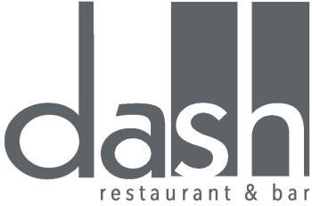
Starters
Beetroot cured salmon, horseradish apple slaw and bread crisps – R120
Asparagus, olive toast, nut crush and parmesan snow – R140
Tempura prawns, pickled soft vegetables and sesame emulsion – R155
Double baked gorgonzola soufflé, biltong shavings and hazelnuts – R125
Caesar salad with anchovy toast and quail eggs – R135
Seared foie gras with apples and shallot marmalade – R230
Seasonal Sorbets
R20 per serving
Main Course
Grilled fillet of beef, spinach purée, melange of vegetables and jus – R295
Pan fried loin of venison, parsley mash and carrot purée – R255
Line fish of the day, lemon butter poached prawns, honey and ginger glazed radishes and a passionfruit and lime sauce – R260
Baby chicken with butternut confit and corn – R200
Vegetable terrine, smoked red pepper coulis, artichokes and hummus – R140
Lamb loin with pearl barley, beetroot puree and roasting jus – R295

Dessert
Hot chocolate fondant with orange ice cream and bitter sugar brittle – R95
Coconut panacotta with lime sorbet and passion fruit coulis – R85
Banana parfait, butterscotch sauce and banoffee – R85
Cape cheese board including Queen Victoria cheddar with preserves and salted breads – R160

